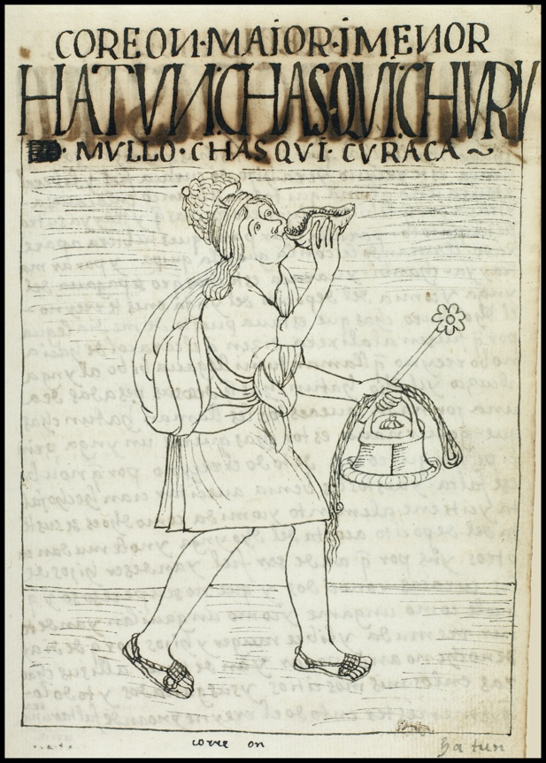
Chasqui: revista de literatura y cultura latinoamericana e indígena

Chasqui is published twice yearly: May and November. Review essays, book reviews, and film reviews are available online at http://ChasquiRLL.org/reviews

For subscriptions/sales information contact:
Prof. Patrick Ridge, Modern & Classical Languages & Literatures
Virginia Tech
331 Major Williams
220 Stanger St
Blacksburg, VA 24061
ptridge@vt.edu

Subscriptions and can be fulfilled online (via PayPal) at http://ChasquiRLL.org/subscribe

SUBSCRIPTIONS 2023 | Individuals | Libraries and Institutions
USA | $40.00 | $55.00
International | $40.00 | $60.00
BACK ISSUES | $15.00 USA / $25.00 International
SPECIAL ISSUES
See website for contents
No.1 Lúcia Helena Costigan, ed. (2004)  $10.00 USA / $20.00 International | From “Excess Friendships” to Cannibalism Revisited: Brazilian and Spanish American Literary and Cultural Encounters
No.2 Nora Glickman & Alejandro  Varderi, eds. (2005)  $15.00 USA / $25.00 International | Bridging Continents: Cinematic and Literary Representations of Spanish and Spanish American Themes
No.3 Marina Pérez de Mendiola, ed. (2006)  $10.00 USA / $20.00 International | Going Transatlantic: Toward an Ethics of Dialogue
No. 4 Darrell B. Lockhart, ed. (2013)  $25.00 USA / $35.00 International | Critical Approaches to Mexican-Jewish Literature /  Aproximaciones críticas a la literatura judeomexicana
No. 5 Fernando Blanco, et al, eds. (2013)  $25.00 USA / $35.00 International | Archivo y Memoria: Culturas subversivas de la memoria en arte, medios, literatura, ensayo, y en la experiencia cotidiana. Latinoamérica 1970-2010

Name_____________________________________________________________________

Academic Affiliation_________________________________________________________

Mailing Address_____________________________________________________________

__________________________________________________________________________

City_______________________________ State________________ Zip Code___________

Country____________________________ E-mail__________________________________

Phone Number______________________________

Amount enclosed $______________ (Please make checks/money orders payable to Chasqui)

